Lex and counts tokens in a C program:

Aim:
To write a program to identify and count the total number of tokens in a given C program, including keywords, identifiers, constants, operators, and special symbols.

Algorithm:
- Start the program.
- Read the C source code until END is entered.
- Ignore whitespace characters.
- Identify keywords and identifiers by scanning alphabetic characters and underscores.
- Identify numeric constants.
- Identify operators and special symbols.
- Increment the token count for each recognized token.
- Display the total number of tokens.
- Stop the program.
Pseudo Code:
BEGIN
total = 0
READ C program until END

FOR each character in the program
IF whitespace THEN
Skip character
ELSE IF word THEN
IF word is a keyword THEN
DISPLAY Keyword
ELSE
DISPLAY Identifier
END IF
total = total + 1
ELSE IF digit THEN
DISPLAY Constant
total = total + 1
ELSE IF operator THEN
DISPLAY Operator
total = total + 1
ELSE IF special symbol THEN
DISPLAY Special Symbol
total = total + 1
END IF
END FOR

DISPLAY total
END

Code:
#include <stdio.h>
#include <string.h>
#include <ctype.h>
char *keywords[] = {
"int", "char", "float", "double", "void",

"if", "else", "for", "while", "do",

"return", "switch", "case", "break",
"continue", "default", "long", "short",
"signed", "unsigned", "const", "static",
"struct", "union", "enum", "sizeof",
"typedef", "extern", "auto", "register",
"volatile", "goto"
};
int isKeyword(char *word)
{
int i;
for (i = 0; i < sizeof(keywords) / sizeof(keywords[0]); i++)
if (strcmp(word, keywords[i]) == 0)
return 1;
return 0;
}
int main()
{
char code[5000], word[100];
int i = 0, j, total = 0;
printf("Enter C program (type END on a new line):\n");

while (fgets(code, sizeof(code), stdin))
{
if (strcmp(code, "END\n") == 0 ||
strcmp(code, "END") == 0)
break;

j = 0;
while (code[j] != '\0')
{
if (isspace((unsigned char)code[j]))
{
j++;
}
else if (isalpha((unsigned char)code[j]) || code[j] == '_')
{
i = 0;
while (isalnum((unsigned char)code[j]) || code[j] == '_')
{
if (i < 99)
word[i++] = code[j];
j++;
}
word[i] = '\0';

if (isKeyword(word))
printf("%s : Keyword\n", word);
else
printf("%s : Identifier\n", word);

total++;
}
else if (isdigit((unsigned char)code[j]))
{
i = 0;
while (isalnum((unsigned char)code[j]) ||

code[j] == '.' || code[j] == '_')
{
if (i < 99)
word[i++] = code[j];
j++;
}
word[i] = '\0';
printf("%s : Constant\n", word);
total++;
}
else if (strchr("+-*/%=<>!&|^", code[j]) != NULL)
{
char op[3] = {code[j], '\0', '\0'};
j++;

if (code[j] != '\0' &&
strchr("=<>!&|", op[0]) != NULL &&
(code[j] == '=' ||
(code[j] == op[0] &&
(op[0] == '&' || op[0] == '|'))))
{
op[1] = code[j++];
}

printf("%s : Operator\n", op);
total++;
}
else if (strchr("(){}[];,.:#", code[j]) != NULL)
{
printf("%c : Special Symbol\n", code[j]);
j++;
total++;
}
else
{
j++;
}
}
}

printf("\nTotal number of tokens = %d\n", total);
return 0;
}

Output:
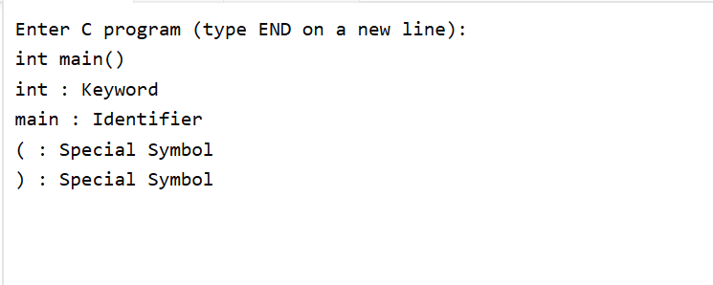

Result:
Thus, the program identifies the different types of tokens in a given C source program and displays the total number of tokens.

